
Información General
Weather. At the bottom of the world the seasons are reversed from the Northern Hemisphere. New Zealand's climate ranges from subtropical in the north to temperate in the South.
Time Tahiti is 12 hours behind GMT, four hours behind US Pacific Standard time and 23 hours behind Australian Eastern Standard time. The sun rises first in New Zealand
Driving Cars drive down the left of the road, like in the UK and opposite of the USA.

An enthralling land of rain forest & glaciers.

Viajes Mundiales SA.
Nueva Zelandia
Viajes Mundiales SA.
Montevideo 6553
Buenos Aires 1123 Argentina
Telephone: 54(1) 821-6543

Qué ver y hacer en Nueva Zelandia

Volcanes
Hot springs, geysers, boiling mud, and volcanoes -- North Island still has a close link with the heart of Mother Earth. The last eruption was in 1996, so the islands of New Zealand are still growing.*
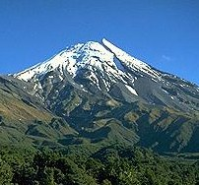

Selva Tropical
Warm, temperate rainforests teem with evergreens and giant tree ferns, a special favorite in New Zealand. Stroll through the shade of unique species and look for giant snail and the giant weta - a cricket-like insect the size of a mouse. Guaranteed harmless!
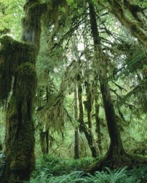
Unique experiences for the Adventurer

Océano y Playas
North Island's beaches match any you've seen. Add to that sailing, fishing, surfing, sand yachts, hang gliders, and jet skis. There is something for the beach bunny and for the extreme sportsman, too. *
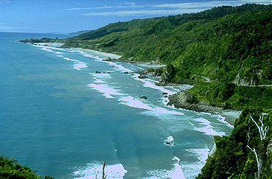

Cuidades
While New Zealand may be "down under", it is not "behind the times." Her cities feature all of the advantages of civilization - fine restaurants, modern architecture, and traffic!
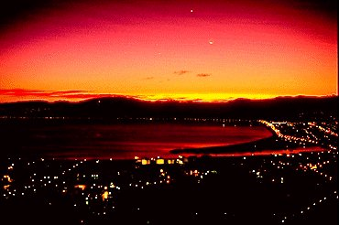

Otras Diversiones
- Snow Skiing
- Golf
- Hang gliding
- Bungee jumping
- Hiking
- Wine tasting -3 world prizewinners!

Call 54 (1) 821-6543
* Some images are the property of Virtual New Zealand - http://www.vnz.co.nz/

