What to See and Do in
New Zealand

Volcanoes
Hot springs, geysers, boiling mud, and volcanoes -- North Island still has a close link with the heart of Mother Earth. The last eruption was in 1996, so the islands of New Zealand are still growing!
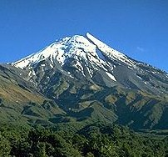

Rain Forests
Warm, temperate rainforests teem with evergreens and giant tree ferns, a special favorite in New Zealand. Stroll through the shade of unique species and look for giant snails and the giant weta - a cricket-like insect the size of a mouse. Guaranteed harmless!
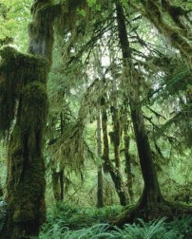
Unique experiences for the Adventurer

Ocean and beaches
North Island's beaches match any you've seen. Add to that sailing, fishing, surfing, sand yachts, hang gliders, and jet skis. There is something for the beach bunny and for the extreme sportsman, too.
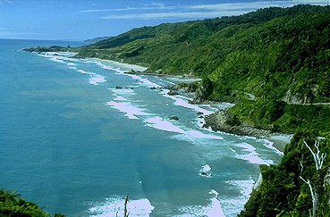

Cities
While New Zealand may be "down under", it is not "behind the times." Her cities feature all of the advantages of civilization - fine restaurants, modern architecture, and traffic!
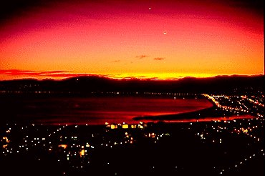

other recreation
- Snow Skiing
- Golf
- Hang gliding
- Bungee jumping
- Hiking
- Wine tasting - 3 world prize winners

General information
Weather At the bottom of the world the seasons are reversed from the Northern Hemisphere. New Zealand's climate ranges from subtropical in the north to temperate in the South.
Time New Zealand is 12 hours ahead of GMT, 16 hours ahead of US Eastern Standard Time. It may be tomorrow already in New Zealand! The sun rises first there.
Driving Cars drive down the left of the road, like in the UK and opposite of the USA.

An enthralling land of rain forest & glaciers.
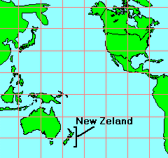

Call 54 (1) 821-6543

* Some images property of Virtual New Zealand

